**U.S. Department of Energy (DOE)  
Clean Energy to Communities (C2C) Program**

Summary of Technical Assistance (TA) Support

|  |
| --- |
| Marker with solid fill |
| Icon  Description automatically generatedBuildings |
| Icon  Description automatically generatedClean Power |
| Climate Mitigation and Resilience |
| Cross-Sectoral Justice |
| A picture containing text, clipart  Description automatically generatedJobs and Economic Development |
| Icon  Description automatically generatedMobility |

**Salem, Oregon**

TA Scope

From August to December 2023, the National Renewable Energy Laboratory (NREL) provided a literature review, content review, and analysis to the City of Salem’s Public Works department. The technical assistance provided included example energy master plans from other communities, a light review of relevant existing plans and policies, advice on planning approaches, boundaries, and assumptions, a checklist of necessary data, recommended methods of analysis and equitable engagement, and an 11-page scope of work document describing a potential city-initiated planning process to be completed by a consultant in the future. The TA team met continuously with the Salem team throughout the process, delivering formal drafts at 30%, 60%, and 90%.

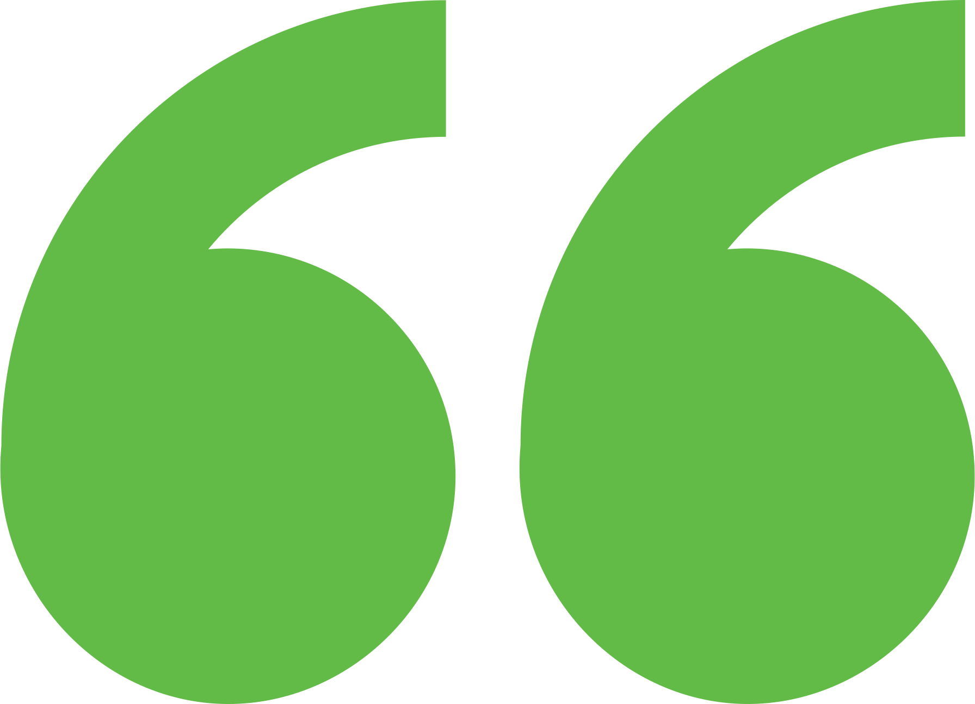 Impact

Salem city staff developed a request for proposals from the scope of work deliverables provided by NREL. They will utilize DOE’s Energy Efficiency and Conservation Block Grant (EECBG) funding to pay for consulting services and have hired a planning staff person to oversee the consultant’s implementation of the energy master planning process. Salem is also participating in C2C Cohorts for Municipal Building Decarbonization, where they will share these deliverables and their experience with other municipal governments. Although this C2C Expert Match offering exceeded the 60-hour limit, TA providers of C2C Cohorts may draw from these deliverables for topic area presentations and templates for developing requests for proposals with other Cohort participants.

Background

Photo goes here.

*Delete this box before publishing.*

**Background**

Ann Arbor is a city of approximately 122,000 people located in southeast Michigan. The city and its residents are leaders in sustainability and climate action. Their A2ZERO Climate Action Plan outlines their just transition pathway to community-wide carbon neutrality by 2030. With equity as a focus, they are implementing strategies to improve home energy efficiency (EE) and electrify appliances. Toward this, the city wants to explore community geothermal heating and cooling to serve a variety of building types including rental and affordable housing. The city has applied to DOE’s Geothermal Heating and Cooling Design and Deployment program and garnered the support of City Council to pursue these projects, but they need to understand the concept’s feasibility in order to make a “go, no-go” decision.

The city of Salem, Oregon, has a population of between 100,000 and 500,000 and is home to state government administrative offices. Salem has an ambitious goal to reduce Green House Gas (GHG) emissions 50% (baseline 2016) by 2035. Their Climate Action Plan (CAP) identifies specific strategies, including energy-specific actions, to reduce emissions. However, city staff do not have the capacity to develop a detailed energy master plan to guide municipal and citywide energy projects. To further advance the strategies of the CAP, the city requested technical assistance from NREL to produce a scope of work for an energy master plan that would form the basis for a project request for proposals, grant application, or other means to make energy-related decisions.

Expert Match Team

**Chrissy Scarpitti**  
Community Lead, Main Expert Match Point of Contact, NREL

**Shanti Pless**  
Researcher, Buildings and Community Energy Planning Expert, NREL

**Sika Gadzanku**  
C2C Expert Match Program Manager, NREL

Community Team

**Heather Dimke**  
Climate Action, Plan Coordinator

**Michael Slater**  
Commissioner, Salem Planning Commission

For more information, visit:  
**energy.gov/eere/clean-energy-communities-program**

August 2024